Supplemental Material for
“Covariate Selection in Causal Learning under Non-Gaussianity”
Illustration of nGFS Output in R

In this supplement, we illustrate the application of the R function nGFS(). The source code of the function is freely available from the first author’s OSF page. To demonstrate the use of the function, we use the real-world data example on numerical cognition given in the main text. Here, we assume that analog magnitude skills (i.e., the Analog Magnitude Code; AMC) constitute a causal precursor of auditory verbal skills (i.e., the Auditory Verbal Code; AVC). Further, in the R code given below, we assume that relevant covariates (i.e., students’ age, pre-existing difficulties with numbers, time needed for test completion, and students’ visual Arabic code skills [VAC]) are given in the data object cov. Figure B1 shows the R code to execute the function together with the resulting output. Using AMC → AVC as the target model leads to the model summarized in the upper section of Figure B1. Here, students’ age, pre-existing difficulties with numbers, and time needed for test completion are returned as admissible covariates. In contrast, using the (theoretically less plausible) model AVC → AMC leads to an empty covariate set (see lower panel of Figure B1).

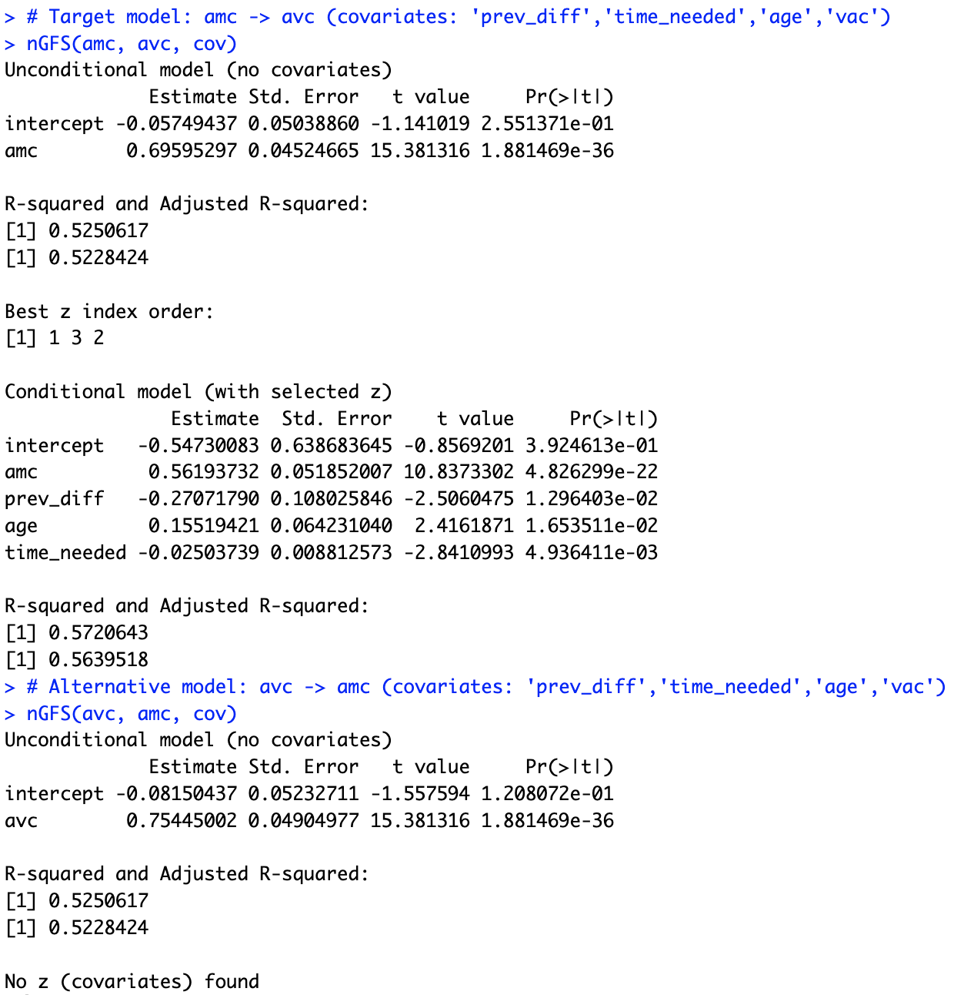
Figure B1. R output for the real-world data example on numerical cognition development (n = 216).

